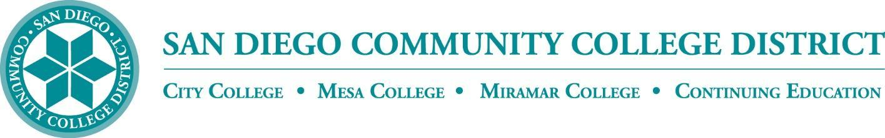

CURRICULUM COMMITTEE

MEETING AGENDA

San Diego Miramar College
Curriculum Committee
December 7, 2022 – 2:30-4:30 PM - https://sdccd-edu.zoom.us/j/96691399291

Members: Jon Alva; Matthew Cain; Paul Chlapecka; Evelyn Escalante-Ruiz; Isabella Feldman; MaryAnn Guevarra; Helen Houillion; Max Moore*; Kelly Morelewski*; Michael Odu; Mara Palma-Sanft; Wayne Sherman; Christopher M. Silva; Alex Stiller-Shulman

* Permanent Guests

- Introductions
- Approval of consent agenda
- Approval of agenda
- Approval of minutes of the previous meeting
- Course proposals
  - New courses
  - Activations
  - Deactivations
  - Distance Learning - No Other Action
  - Revisions
    - CHEM 152 Introduction to General Chemistry
City, Mesa, Miramar (Mesa-originating)
    - MATH 151 Calculus with Analytic Geometry II
Mesa, Miramar, City (Mesa-originating)
    - MATH 252 Calculus with Analytic Geometry III
City, Mesa, Miramar (Mesa-originating)
    - MATH 254 Introduction to Linear Algebra
City, Mesa, Miramar (Mesa-originating)
    - MATH 255 Differential Equations
City, Mesa, Miramar (Mesa-originating)
    - SPAN 210 Conversation and Composition Spanish I
City, Mesa, Miramar (Mesa-originating)
    - SPAN 211 Conversation and Composition Spanish II
City, Mesa, Miramar (Mesa-originating)
- Award proposals
  - New awards
  - Deactivations
  - Revisions
- Subject Area Indicators
  - PSMA (Public Safety Management) Subject Area Indicator
Miramar (Miramar-originating)
- Other business
- Next Scheduled Meeting:
  - Wednesday, 2/1/23, at 2:30 PM
- FYIs
    - AB 1111 Common Course Numbering Project (impact on classes required for general education and transfer pathways, rather than all courses)
      - Link/reference: AB 1111 Sacramento Workgroup - Recording of The California Community Colleges Common Course Numbering Task Force event on 11/29
    - Ethnic Studies GE requirement
    - AB 928 Singular GE Pathway
- Reports
  - Vice President of Instruction
  - Evaluators
  - Articulation Officer
  - Curriculum Chair
- Roundtable
Consent Agenda

FYIs - Proposals for courses/awards/etc. not offered at Miramar, or distance education at the sister colleges

- New courses
- Course activations
- Course deactivations
- Course reactivations
- Distance education at City
- Distance education at Mesa
- New awards
  - Electronic Manufacturing Certificate of Performance
City (City-originating)
- Award deactivations
- Award revisions
  - Film, Television, and Electronic Media Associate in Science for Transfer Degree
City (City-originating)
  - Liberal Arts and Sciences: Scientific Studies Mathematics and Pre-Engineering Associate of Arts Degree
City (City-originating)
  - Theatre Associate of Arts Degree
City (City-originating)
- Subject Area Indicators

