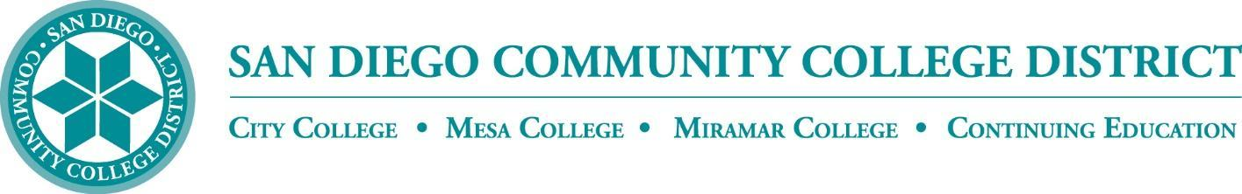

CURRICULUM COMMITTEE

MEETING AGENDA

San Diego Miramar College
Curriculum Committee
November 2, 2022 – 2:30-4:30 PM - https://sdccd-edu.zoom.us/j/96691399291

Members: Jon Alva; Matthew Cain; Paul Chlapecka; Evelyn Escalante-Ruiz; Isabella Feldman; MaryAnn Guevarra; Helen Houillion; Max Moore*; Kelly Morelewski*; Michael Odu; Mara Palma-Sanft; Wayne Sherman; Christopher M. Silva; Alex Stiller-Shulman

* Permanent Guests

- Introductions
- Approval of consent agenda
- Motion to approve by Wayne Sherman; Seconded by Matthew Cain; motion carried
- Approval of agenda
- Motion to approve by Wayne Sherman; seconded by Isabella Feldman. motion carried
- Approval of minutes of the previous meeting
- Motion to approve by Wayne Sherman; seconded by Matthew Cain; motion carried
- Course proposals
  - New courses
  - Activations
  - Deactivations
  - Distance Learning - No Other Action
  - Revisions
    - EXSC 285 Exercise for Special Populations
City, Mesa, Miramar (Mesa-originating)
- Motion to approve by Matthew Cain; seconded by Wayne Sherman. motion carried
    - SPAN 202 Fourth Course in Spanish
City, Mesa, Miramar (Mesa-originating)
- Questioned about the language on SLO (item #7) and Outline (item # 9D)
- Motion to approve by Wayne Sherman; seconded by Mara Palma-Sanft. Motion carried with recommendation.

- Award Proposals
  - New awards
  - Deactivations
  - Revisions
- Other business
  - Discussion of ABs/SBs/etc.:
- AB 1111 (Shelly)
- AB 1705
- AB 1701
- AB 102
- AB 1187
- AB 2881
- SB 1114
- AB 1942
- AB 1232
- AB 1958
- AB 1998
- AB 2459
- AB 2747
- AB 2810
- SB 641
- SB 851
- AB 111: Take a “pause” on major curriculum changes until the District Office will receive more guidance from the state in order to minimize impact in all office and confusion among students
- AB 1705: Cannot require or recommend students to take pretransfer-level english or math classes. There are two implementation dates – July 1, 2023 for basic skills and July 1, 2024 for stem-level courses. District will provide more info after the District-wide Assessment Meeting on Nov 18th at 1:00-2:30 p.m. via Zoom. All are welcome to attend.
- AB 102: Removed sunset date related to pupil attendance at community college
- AB 1187: Implemented EDUC 044A-D effective this Fall 2022 to claim apportionment for tutoring services
- AB 1942: Will impact Miramar’s ISA contracts
- More info: Legislative Overview, Impacts, and (Tentative) District Project Plans
  - City’s Cyber Defense and Analysis (CYDA) Subject Indicator
- Networking and technology courses at City. Upper level courses for baccalaureate program
- City is asking to support and offer feedback on subject indicator. Contact Jen Boots of City for more questions.
3. Ethnic Studies GE requirement – Mara: no change on Area 7 for IGETC.
- AB 928 Singular GE Pathway
- No change on CalGETC Singular Pathway.
- Received “Three Pathways Side by Side” document: Proposed CalGETC Pathway, Proposed CCC Associate Degree GE Pathway, and Proposed CCC Baccalaureate Degree GE Pathway (Lower Division)
- Baccalaureate lower degree pathway is only proposed; not have gone far yet
  - AB 927 – still working on Miramar may be submitting for January cycle
- Next Scheduled Meeting:
  - Wednesday, 11/16, at 2:30 PM
- FYIs Reports
  - Vice President of Instruction
  - Evaluators
  - Articulation Officer
- Miramar submitted BLAS 100, 140A and 140B for CSU GE
  - Curriculum Chair
- Roundtable
- Effective 11/2/2022, Helen Houillion is no longer a voting committee member, but will continue to participate in future Curriculum Review Committee meetings as a guest member only. Evelyn Escalante is Helen’s replacement as the voting committee member.
Consent Agenda

FYIs - Proposals for courses/awards/etc. not offered at Miramar, or distance education at our sister colleges

- New courses
  - ENGL 402 Advanced Technical Writing
City (City-originating)
- Course activations
- Course deactivations
  - MUSI 209C Recording Studio Internship III
Mesa (Mesa-originating)
  - MUSI 209D Recording Studio Internship IV
Mesa (Mesa-originating)
  - MUSI 248B Music Theory IV
Mesa (Mesa-originating)
  - MUSI 269B Ear Training IV
Mesa (Mesa-originating)
- Course reactivations
- Distance education at City
- Distance education at Mesa
- New awards
- Award deactivations
- Award revisions
- Subject Area Indicators
  - City’s CYDA (Cyber Defense and Analysis) Subject Area Indicator

