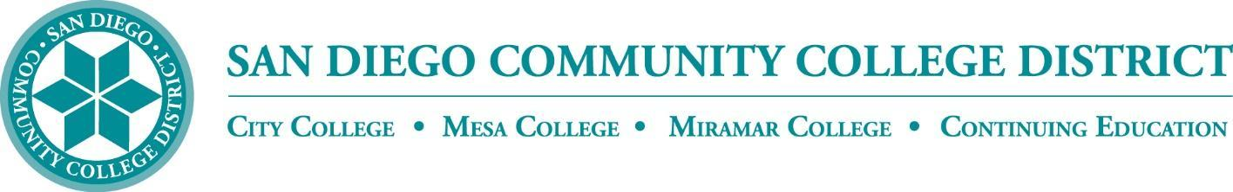

CURRICULUM COMMITTEE

MEETING AGENDA

San Diego Miramar College
Curriculum Committee
November 16, 2022 – 2:30-4:30 PM - https://sdccd-edu.zoom.us/j/96691399291

Members: Jon Alva; Matthew Cain; Paul Chlapecka; Evelyn Escalante-Ruiz; Isabella Feldman; MaryAnn Guevarra; Helen Houillion; Max Moore*; Kelly Morelewski*; Michael Odu; Mara Palma-Sanft; Wayne Sherman; Christopher M. Silva; Alex Stiller-Shulman

* Permanent Guests

- Introductions
- Approval of consent agenda
- Approval of agenda
- Approval of minutes of the previous meeting
- Course proposals
  - New courses
  - Activations
  - Deactivations
  - Distance Learning - No Other Action
  - Revisions
    - BUSE 100 Introduction to Business
City, Mesa, Miramar (Miramar-originating)
    - WORK 270 Occupational Work Experience
City, Mesa, Miramar (Mesa-originating)
    - HUMA 106 World Religions
City, Mesa, Miramar (Mesa-originating)
    - MUSI 150A Basic Musicianship
City, Mesa, Miramar (Mesa-originating)
- Award proposals
  - New awards
  - Deactivations
    - Accountancy for Enrolled Agents Certificate of Achievement
Miramar (Miramar-originating)
  - Revisions
- Other business
  - Ethnic Studies GE requirement
  - AB 928 Singular GE Pathway
- Next Scheduled Meeting:
  - Wednesday, 12/7, at 2:30 PM
- FYIs
- Reports
  - Vice President of Instruction
  - Evaluators
  - Articulation Officer
  - Curriculum Chair
- Roundtable
Consent Agenda

FYIs - Proposals for courses or awards not offered at Miramar, or distance education at the sister colleges

- New courses
  - BUSE 440 Cyber Law and Ethics
City (City-originating)
  - CISC 450 Security Analytics and Visualization
City (City-originating)
- Course activations
- Course deactivations
  - BUSE 090A Learning Skills
City (City-originating)
  - BUSE 090B Work Success
City (City-originating)
  - BUSE 090C Business Internship Seminars
City (City-originating)
  - BUSE 090D Workplace Competencies
City (City-originating)
  - BUSE 122 Sports Management
City (City-originating)
  - BUSE 124 Sports Sales
City (City-originating)
  - CHIL 155 Supervised Field Study Seminar
City, Mesa (City-originating)
- Course reactivations
- Distance education at City
- Distance education at Mesa
- New awards
- Award deactivations
  - Business Communications and Cultural Competence Certificate of Performance
City (City-originating)
  - Business Presentations* Certificate of Performance
City (City-originating)
  - Certified Public Accountant (CPA) Preparatory Program Certificate of Achievement
City (City-originating)
  - Job Skills Certificate of Performance
City (City-originating)
  - Sports Management Certificate of Performance
* City (City-originating)
  - Working Education* Certificate of Performance
* City (City-originating)
- Award revisions
  - Music Associate in Arts for Transfer Degree
Mesa (Mesa-originating)
  - Music Theory Certificate of Achievement
Mesa (Mesa-originating)
- Subject Area Indicators

