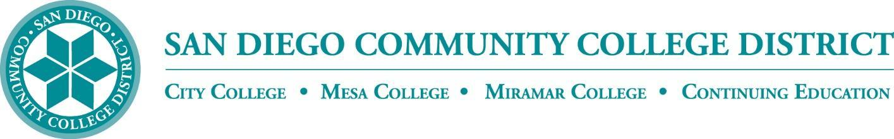

CURRICULUM COMMITTEE

MEETING AGENDA

San Diego Miramar College
Curriculum Committee
November 2, 2022 – 2:30-4:30 PM - https://sdccd-edu.zoom.us/j/96691399291

Members: Jon Alva; Matthew Cain; Paul Chlapecka; Evelyn Escalante-Ruiz; Isabella Feldman; MaryAnn Guevarra; Helen Houillion; Max Moore*; Kelly Morelewski*; Michael Odu; Mara Palma-Sanft; Wayne Sherman; Christopher M. Silva; Alex Stiller-Shulman

* Permanent Guests

- Introductions
- Approval of consent agenda
- Approval of agenda
- Approval of minutes of the previous meeting
- Course proposals
  - New courses
  - Activations
  - Deactivations
  - Distance Learning - No Other Action
  - Revisions
    - ENGL 402 Advanced Technical Writing
City (City-originating)
    - EXSC 285 Exercise for Special Populations
City, Mesa, Miramar (Mesa-originating)
    - SPAN 202 Fourth Course in Spanish
City, Mesa, Miramar (Mesa-originating)
- Award Proposals
  - New awards
  - Deactivations
  - Revisions
    - Economics Associate in Arts for Transfer Degree
Miramar (Miramar-originating)
    - Independent Business Ownership Certificate of Performance
Miramar (Miramar-originating)
- Other business
  - Discussion of ABs/SBs/etc.:
    - AB 1111
    - AB 1705
    - AB 1701
    - AB 102
    - AB 1187
    - AB 281
    - SB 1114
    - AB 1942
    - AB 1232
    - AB 1958
    - AB 1998
    - AB 2459
    - AB 2747
    - AB 2810
    - SB 641
    - SB 851
      - More info: Legislative Overview, Impacts, and (Tentative) District Project Plans
  - Ethnic Studies GE requirement
  - AB 928 Singular GE Pathway
- Next Scheduled Meeting:
  - Wednesday, 11/16, at 2:30 PM
- FYIs
- Reports
  - Vice President of Instruction
  - Evaluators
  - Articulation Officer
  - Curriculum Chair
- Roundtable
Consent Agenda

FYIs - Proposals for courses/awards/etc. not offered at Miramar, or distance education at our sister colleges

- New courses
  - ENGL 402 Advanced Technical Writing
City (City-originating)
- Course activations
- Course deactivations
  - MUSI 209C Recording Studio Internship III
Mesa (Mesa-originating)
  - MUSI 209D Recording Studio Internship IV
Mesa (Mesa-originating)
  - MUSI 248B Music Theory IV
Mesa (Mesa-originating)
  - MUSI 269B Ear Training IV
Mesa (Mesa-originating)
- Course reactivations
- Distance education at City
- Distance education at Mesa
- New awards
- Award deactivations
- Award revisions
- Subject Area Indicators
  - City’s CYDA (Cyber Defense and Analysis) Subject Area Indicator

