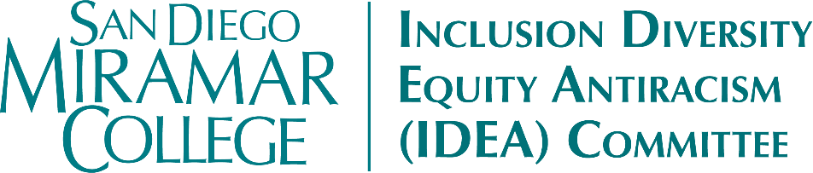

**~ Agenda ~**

**Sept 16 @ 11:30AM**

**New Business:**

1. Many Thanks to Terrie Hubbard ~ IDEA Co-Chair
2. CDAC District Meeting
3. Equity Summit Discussion
4. Update on International Education
5. Funding Requests/ Standing Item
6. New request (s)

**Old Business:**

1. Student Equity Plan (SEP) Review & Update/ Standing Item for Fall 2022
2. Latinx Heritage Month Events:
3. Sept 20; (Bear Wolf)
4. Sept 30; (April Koch)
5. TBA: (Javier Gonzalez-Meeks)
6. Fall Calendar & Events to consider ~
7. Disability Awareness Month: Oct (TBA: Judy Heumann – Session with Students)
8. Filipinx American History Month: Oct
9. LGBT History Month: Oct
10. Native American Heritage Month: Nov
11. International Ed Week: Nov
12. Any Additional events to consider?

**Announcement(s):**

IDEA will meet the 1st & 3rd Fri for Fall until Dec 2

Oct 7 & 21; Nov 4 & 18; Dec 2

Other Announcements: Article & Info on Impact of COVID on BIPOC communities

**Adjournment**

**San Diego Miramar College 2020 – 2027 Strategic Goals**

**Goal 1**: Pathways – Provide student-centered pathways that are responsive to change and focus on student learning, equity, and success

**Goal 2**: Engagement-Enhance the college experience by providing student-centered programs, curriculum, services, and activities that close achievement gaps, engage students, and remove barriers to their success

**Goal 3**: Organizational Health-Strengthen Institutional Effectiveness through planning, outcomes assessment, and program review processes in efforts to enhance data-informed decision making

**Goal 4**: Relationship Cultivation - Build and sustain a college culture that strengthens participatory governance, equity efforts, and community partnerships

**Goal 5**: Diversity, Equity, and Inclusion (DEI)-Build an environment that embraces diversity, equity, inclusion, anti-racism, and social justice for the benefit of the college community