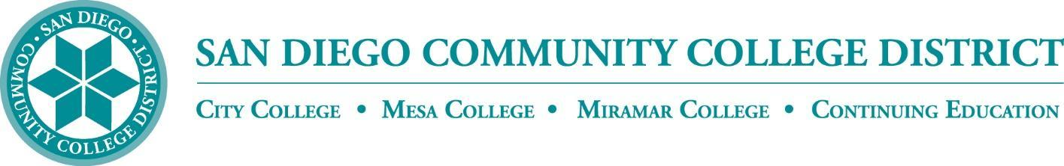

CURRICULUM COMMITTEE

DRAFT MEETING AGENDA

San Diego Miramar College
Curriculum Committee
September 7, 2022 – 2:30-4:30 PM - https://sdccd-edu.zoom.us/j/96691399291 (password: crc)

Members: Jon Alva; Matthew Cain; Melanie Cordero; Evelyn Escalante-Ruiz; Isabella Feldman; MaryAnn Guevarra; Helen Houillion; Eli Jed Manalastas; Max Moore*; Kelly Morelewski*; Michael Odu; Paul Chlapecka; Mara Palma-Sanft; Wayne Sherman; Christopher M. Silva; Alex Stiller-Shulman

*Permanent Guests
- Approval of agenda
- Introductions
- Approval of minutes from last meeting
- Approval of consent agenda
- Course proposals
  - New courses
  - Activations
  - Deactivations
    - ENGL 042 College Reading and Study Skills I
Miramar * (Miramar-originating)
    - ENGL 043 English Review
Miramar * (Miramar-originating)
  - Distance Learning - No Other Action
    - PHYS 125 General Physics
Miramar * (Miramar-originating)
    - PHYS 126 General Physics II
Miramar * (Miramar-originating)
    - PHYS 180A General Physics I
Miramar * (Miramar-originating)
    - PHYS 180B General Physics II
Miramar * (Miramar-originating)
    - PHYS 195 Mechanics
Miramar * (Miramar-originating)
    - PHYS 196 Electricity and Magnetism
Miramar * (Miramar-originating)
  - Revisions
    - CHEM 200 General Chemistry I - Lecture
City, Mesa, Miramar * (Miramar-originating)
    - CHEM 200L General Chemistry I - Laboratory
City, Mesa, Miramar * (Miramar-originating)
    - CHEM 201 General Chemistry II - Lecture
City, Mesa, Miramar * (Miramar-originating)
    - CHEM 201L General Chemistry II - Laboratory
Mesa, Miramar, City * (Miramar-originating)
    - CISC 179 Introduction to Python Programming
City, Mesa, Miramar * (Mesa-originating)
    - EMGM 105A Emergency Medical Technician - National Registry
Miramar * (Miramar-originating)
    - ENGL 031 Academic Literacy
City, Mesa, Miramar * (Mesa-originating)
    - EXSC 242B Care and Prevention of Injuries
City, Mesa, Miramar * (Mesa-originating)
    - PHIL 100 Logic and Critical Thinking
City, Mesa, Miramar * (Miramar-originating)
    - PHYS 125 General Physics
City, Mesa, Miramar * (Miramar-originating)
- Award Proposals
  - New awards
    - Title: Hawthorne Technician Apprenticeship (HTAP) ***Certificate of Achievement***
Miramar * (Miramar-originating)
    - Title: Hawthorne Technician Apprenticeship (HTAP) ***Associate of Science Degree***
Miramar * (Miramar-originating)
  - Deactivations
  - Revisions
- Other business
  - Ethnic Studies GE requirement
  - AB 928 Singular GE Pathway
  - Dr. Shelly Hess (with Curriculum Services): Annual Presentation for 9/21
  - New CIC Catalog Deadline is Sep 22, 2022 (for Fall 2024 catalog)
- Next Scheduled Meeting:
  - Wednesday, 9/21, at 2:30 PM
- Reports
  - Vice President of Instruction
  - Evaluators
  - Articulation Officer
  - Curriculum Chair
- Roundtable

Consent Agenda

FYIs - Proposals for courses or awards not offered at Miramar, or distance education at our sister colleges

- New courses
  - ARTF 208B Ceramic Production II
City * (City-originating)
- Course activations
- Course deactivations
  - PHYN 215 Introduction to Teaching Science
Mesa * (Mesa-originating)
- Course reactivations
- Distance education at City
- Distance education at Mesa
- New awards
  - Title: Information and Communication Technology ***Certificate of Performance***
Mesa * (Mesa-originating)
  - Title: Microsoft Excel Essentials ***Certificate of Performance***
City * (City-originating)
  - Title: Microsoft Office Essentials ***Certificate of Performance***
City * (City-originating)
- Award deactivations
  - Title: Business Administration ***Associate in Science for Transfer Degree***
Mesa * (Mesa-originating)
- Award revisions
  - Title: Mental Health Work ***Certificate of Achievement***
City * (City-originating)

