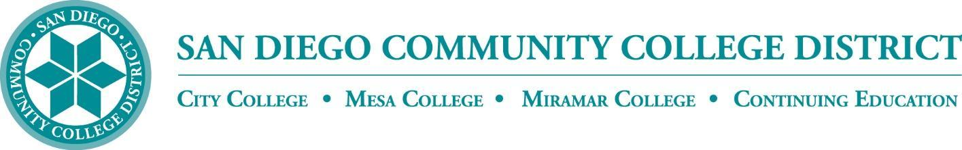

CURRICULUM COMMITTEE

MEETING AGENDA

San Diego Miramar College
Curriculum Committee
May 18, 2022 – 2:30-4:30 PM - https://cccconfer.zoom.us/j/96691399291
(password: crc)

Members: Jon Alva; Matthew Cain; Isabella Feldman; MaryAnn Guevarra; Max Moore*; Kelly Morelewski*; Michael Odu; Larry Pink; Mara Palma-Sanft; Wayne Sherman; Alex Stiller-Shulman; Ryan Zimmerman

*Permanent Guests
- Approval of agenda
- Introductions
- Approval of minutes from last meeting
- Approval of consent agenda
- Approval of meeting dates for 2022-2023 academic year
- Course proposals
  - New courses
  - Activations
  - Deactivations
    - ACCT 210 Partnerships, Gift Tax, and Estate and Trusts Tax for Enrolled Agents
Miramar * (Miramar-originating)
    - ACCT 211 Corporate Taxation for Enrolled Agents
Miramar * (Miramar-originating)
    - ACCT 212 Representation, Practices, and Procedures for Enrolled Agents
Miramar * (Miramar-originating)
    - ENGL 042 College Reading and Study Skills I
Miramar * (Miramar-originating)
    - ENGL 043 English Review
Miramar * (Miramar-originating)
  - Revisions
    - BANK 102 Mortgage Brokerage and Banking *Pending*
Miramar * (Miramar-originating)
    - BUSE 155 Small Business Management
Mesa, City, Miramar * (Mesa-originating)
    - EXSC 270 Exercise Science Internship / Work Experience
City, Mesa, Miramar * (City-originating)
    - EXSC 286 Techniques of Exercise Leadership
City, Mesa, Miramar * (City-originating)
    - MATH 150 Calculus with Analytic Geometry I
City, Mesa, Miramar * (City-originating)
    - PHIL 101 Symbolic Logic
City, Mesa, Miramar * (Mesa-originating)
    - PHIL 131 Environmental Ethics
Mesa, Miramar, City * (Mesa-originating)
    - PHYS 125 General Physics
City, Mesa, Miramar * (Miramar-originating)
    - PSYC 123 Adolescent Psychology
City, Miramar * (City-originating)
- Award Proposals
  - New awards
    - Title: Hawthorne Technician Apprenticeship (HTAP) ***Certificate of Achievement***
Miramar * (Miramar-originating)
    - Title: Hawthorne Technician Apprenticeship (HTAP) ***Associate of Science Degree***
Miramar * (Miramar-originating)
  - Deactivations
  - Revisions
- Other business
  - Ethnic Studies GE requirement
  - AB 928 Singular GE Pathway
  - Meeting dates for 2022-2023 academic year
- Reports
  - Vice President of Instruction
  - Evaluators
  - Articulation Officer
  - Curriculum Chair
- Roundtable

Consent Agenda

FYIs - Proposals for courses or awards not offered at Miramar, or distance education at sister colleges

- New courses
- Course activations
- Course deactivations
  - ENGL 012A Basic English Review
City (City-originating)
  - ENGL 021A Introduction to Academic Literacy
City (City-originating)
- Course reactivations
- Distance education at City
  - PSYC 135 Marriage and Family Relations
City, Mesa, Miramar * (City-originating)
  - PSYC 161 Introduction to Counseling
City, Mesa, Miramar * (City-originating)
- Distance education at Mesa
- New awards
  - Title: Microsoft Excel Essentials ***Certificate of Performance***
City * (City-originating)
  - Title: Microsoft Office Essentials ***Certificate of Performance***
City * (City-originating)
- Award deactivations
- Award revisions
  - Title: Philosophy ***Associate of Arts Degree***
City * (City-originating)

