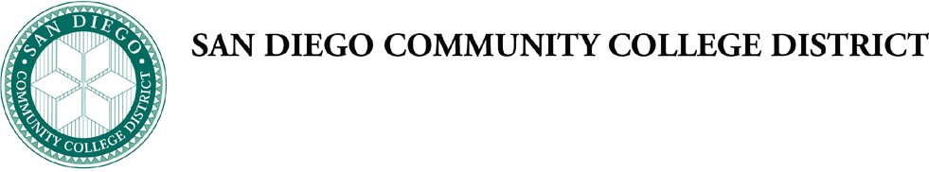

Board of Trustees Policy Chapter 4 - Instructional Services

BP 5152 MILITARY EDUCATION PROGRAM CONTRACTING

The District is committed to the highest standards of ethical conduct and transparency in all business transactions, including in the procurement, execution and fulfillment of contracts in the Military Education Program. The District complies with the Federal Acquisition Regulation (FAR), applicable Executive Orders, and Office of Management and Budget (OMB) circulars in its contracting activities with the Federal government.

FORMS AND REFERENCES
No forms or references.

Adopted: 03/27/2014

SUPERSEDES
New policy.

