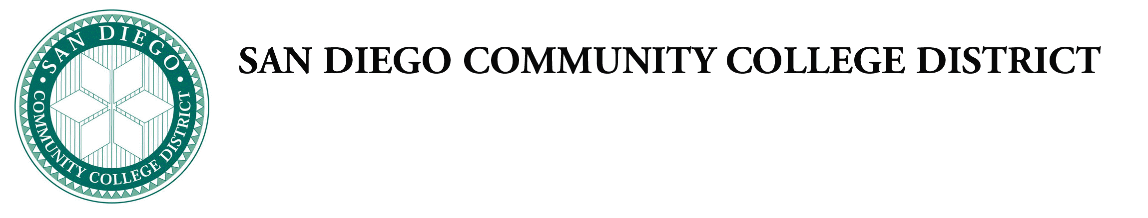
Administrative Procedures

Chapter 4—Instructional Services

Chancellor’s Cabinet First Reading:
Chancellor’s Cabinet Second Reading:
DGC First Reading:
DGC Second Reading:

The following Board Policies are being put forth for approval as part of the Board’s ongoing 6-year comprehensive review of all Board policies and procedures.

Category 1 Procedures New and/or major revisions to policies and/or procedures that are not required by law or regulation, but are recommended by the respective office of responsibility.

AP 4025.1 Philosophy and Criteria for Certificates
Revised Procedure: Change number to align with CCLC formatting and minor technical revisions to align language with title 5.

AP 4025.2. Philosophy and Criteria for Baccalaureate Degrees
New Procedure: This new procedure formalizes the process for developing and approving baccalaureate degrees.

AP 4105 Distance Education
Revised Procedure: Change number to align with CCLC formatting and minor technical revisions to align language with title 5 and ACCJC/WASC revisions.

AP 4260 Prerequisites, Corequisites, Limitations on Enrollment, and Advisories
Revised Procedure: Change number to align with CCLC formatting and minor technical revisions to align language with title 5.

AP 4400 Community Service Offerings
New Procedure: This new legally required procedure formalizes the process for developing and approving community service offerings.

