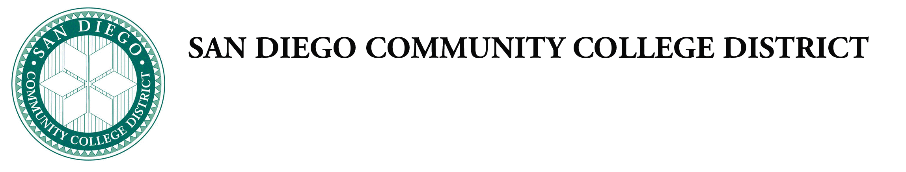
Administrative Procedure

Chapter 4—Academic Affairs Instructional Services

AP 4025.1 PHILOSOPHY AND CRITERIA FOR CERTIFICATES

Chancellor’s Cabinet First Reading:
Chancellor’s Cabinet Second Reading:
DGC First Reading:
DGC Second Reading:

All certificates and diplomas must comply with national and state statutes, regulations, District policy, local approval and/or accrediting agencies, good practice, and the philosophy, mission, and goals of the institution.

This procedure implements:

Certificates of Achievement
Certificates of Achievement that may appear by name on a student transcript or diploma require California Community Colleges Chancellor’s Office approval.

The following is required for all Certificates of Achievement:
- Completion of all required courses in the certificate with a grade of “C” or better. A “P” (pass) grade meets this requirement;
- Meet all standards for Admission to the desired certificate program where applicable; and
- A minimum of six semester units of required courses in the certificate completed in residence at any of the colleges in the San Diego Community College District college awarding the certificate any of the District colleges.
- Completion of all required courses in the certificate with a grade of “C” or better. a “P” (pass) grade meets this requirement.

Certificates of Performance
Certificates of Performance, not to exceed 15 1/2 units, are locally approved department awards that are not recorded on the official transcripts. not to exceed 15 1/2 units (not to exceed 17 1/2) units that are not recorded on the official transcripts.

The following is required for all Certificates of Performance:
- Complete all required courses in the certificate with a grade of “C” or better. A “P” (pass) grade meets this requirement; and
- Complete aAll courses required for the certificate must be completed in residence at any of the colleges in the San Diego Community College District. Course substitutions or course equivalencies from other colleges may not be used to satisfy certificate of performance requirements.

Certificates of Completion
Certificates of completion that may appear by name on a student transcript require California Community Colleges Chancellor’s Office approval.

The following is required for all Certificates of Completion:
- Complete all required courses in the certificate.
- Complete all All courses required for the certificate must be completed in residence at Continuing Education in the San Diego Community College District. Course substitutions or course equivalencies from other colleges may not be used to satisfy certificate of completion performance requirements.

Certificates of Competency
Certificates of competency completion that may appear by name on a student transcript require California Community Colleges Chancellor’s Office approval.
The following is required for all Certificates of Competency:
- Complete all required courses in the certificate.
Complete all All courses required for the certificate must be completed in residence at Continuing Education in the San Diego Community College District. Course substitutions or course equivalencies from other colleges may not be used to satisfy certificate of competency performance requirements.

High School Diploma Programs
High School Diploma Programs that may appear by name on a student transcript require California Community Colleges Chancellor’s Office approval.

The following is required for all High School Diploma Programs:
To receive a joint high school diploma from the San Diego Continuing Education program in cooperation with the San Diego Unified School District Adult Education students must complete all required courses in the program in either Option 1 or Option 2 in the current catalog.
- Under Option 1, students must earn a total of 40 semester credits:
  - Credit for appropriate senior high (grade 9-12) courses taken in Grades 7 or 8 may be applied to a high school diploma;
  - Credit may be given for previous education, but no high school credit may be awarded for religion classes.
- Under Option 2, students must earn a minimum of 24 semester credits or equivalent. Credits may be given for previous education.

References: California Code of Regulations Title 5: Sections 51022, 55060 et Seq., 55070,
55072, 55130, 55600 et seq.
Education Code: Section 70901, 70902, 78106 WASC/ACCJC Accreditation Standards: II.A, II.A.3

Approved by the Chancellor:
Supersedes: 2/10/2017

