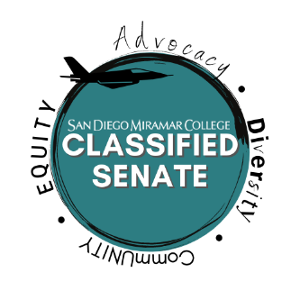
SAN DIEGO MIRAMAR COLLEGE

CLASSIFIED SENATE MEETING AGENDA

DATE: Dec. 7th, 2021 TIME: 11:00 AM – 12:00 PM LOCATION: Zoom

Officers and Senators

Sean Young, Val Sacro, Arnice Neff, Sandra Marquez, Bill Pacheco, Sam Shooshtary, Clarissa Padilla, Sharilyn Wilson, Jill Dela Cruz, Rachel Halligan, Calvin Le, Ryan Roper, Lezlie Allen, Jill Griggs, Anna Liza Manzo

Vacancies

Senator Area B, Senator Area C, Senator Area D

- Call to Order

- Approval of Agenda and Minutes
- Classified Senate Meeting (5 mins.) – Nov. 2nd, Nov. 16th

- Additional Items:
  - Equity*

- Old Business:

# | Item | Strategic Goal(s) | Accreditation Standard | Initiator
1 | Vote to Hold remaining Senate meeting for 2021 via Zoom – Action Item (2 Mins.) | 4 | IV | Sean Young
2 | Vote for Meeting Modality for Spring 2022 – Action Item (2 Mins.) | 4 | IV | Sean Young

- New Business:

# | Item | Strategic Goal(s) | Accreditation Standard(s) | Initiator
1 | San Diego Miramar College Planning Cycle Alignment – Discussion Item (15 mins.) | 3, 4 | I | Daniel Miramontez
2 | 2021-2024 Collegewide Program Review & Outcomes Assessment Plan. – Discussion Item (15 mins.) | 2, 3, 4 | I, II, III | Patricia Manley
3 | College Governance Handbook Change Request Processes and Meeting Modality for Governance Committees – Action Item (15 mins.) | 3,4 | I, IV | Sean Young
4 | Tentative Classified Senate Schedule for Spring 2022 – Action Item (5 mins.) | 4 | IV | Sean Young
5

- Announcements and Open Comment
- Spring Kickoff will be held on January 27th, 2022 and will be held in person.
- Adjournment

- Next Scheduled Meeting

- TBD based upon approved tentative schedule

*Additional Items will be addressed based upon time.

San Diego Miramar College 2020 – 2027 Strategic Goals

- Pathways - Provide student-centered pathways that are responsive to change and focus on student learning, equity, and success
- Engagement - Enhance the college experience by providing student-centered programs, services, and activities that close achievement gaps, engage students, and remove barriers to their success
- Organizational Health - Strengthen Institutional Effectiveness through planning, outcomes assessment, and program review processes in efforts to enhance data-informed decision making
- Relationship Cultivation - Build and sustain a college culture that strengthens participatory governance, equity efforts, and community partnerships
- Diversity, Equity, and Inclusion - Build an environment that embraces diversity, equity, inclusion, anti-racism, and social justice for the benefit of the college community

** ACCJC Accreditation Standards (Adopted June 2014)

  - Mission, Academic Quality and Instructional Effectiveness, and Integrity.
  - Student Learning Programs and Support Services.
  - Resources
  - Leadership and Governance.

