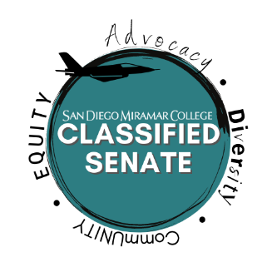**SAN DIEGO MIRAMAR COLLEGE**

**CLASSIFIED SENATE MEETING AGENDA**

**DATE: Nov. 16th, 2021 TIME: 11:00 AM – 12:00 PM LOCATION: Zoom**

**Officers and Senators**

Sean Young, Val Sacro, Arnice Neff, Sandra Marquez, Bill Pacheco, Sam Shooshtary, Clarissa Padilla, Sharilyn Wilson, Jill Dela Cruz, Rachel Halligan, Calvin Le, Ryan Roper, Lezlie Allen, Jill Griggs, Anna Liza Manzo, Jeanette Moore

**Vacancies**

Senator Area B, Senator Area D

1. **Call to Order**
2. **Approval of Agenda and Minutes**
3. Approval of Agenda
4. Classified Senate Meeting Minutes – Nov. 2nd, 2021
5. **Additional Items:** 
   1. Equity*
6. **Old Business:**

|  |  |  |  |  |
| --- | --- | --- | --- | --- |
| **#** | **Item** | **Strategic Goal(s)** | **Accreditation Standard** | **Initiator** |
|  | Continued discussion on Meeting Modality for Spring 2021. | 4 | IV | Sean Young |

1. **New Business:**

|  |  |  |  |  |
| --- | --- | --- | --- | --- |
| **#** | **Item** | **Strategic Goal(s)** | **Accreditation Standard(s)** | **Initiator** |
| 1 | Shared Governance Committee Change Process and Taskforce to Review Committee Changes – Information Item | 4 | IV | Sean Young |
| 2 | College Membership in HACU, Hispanic Association of Colleges and Universities - Information Item | 1, 2 | II, III | Sean Young |
| 3 | Participatory Governance Training Timeline and Topics Draft – Information Item | 4 | IV | Sean Young |

1. **Announcements and Open Comment**
2. **Adjournment**
3. **Next Scheduled Meeting**

* Dec. 7th, 2021 at 11:00 AM -12:00 PM

*Additional Items will be addressed based upon time.

**San Diego Miramar College 2020 – 2027 Strategic Goals**

1. **Pathways** - Provide student-centered pathways that are responsive to change and focus on student learning, equity, and success
2. **Engagement** - Enhance the college experience by providing student-centered programs, services, and activities that close achievement gaps, engage students, and remove barriers to their success
3. **Organizational Health** - Strengthen Institutional Effectiveness through planning, outcomes assessment, and program review processes in efforts to enhance data-informed decision making
4. **Relationship Cultivation** - Build and sustain a college culture that strengthens participatory governance, equity efforts, and community partnerships
5. **Diversity, Equity, and Inclusion** - Build an environment that embraces diversity, equity, inclusion, anti-racism, and social justice for the benefit of the college community

** **ACCJC Accreditation Standards (Adopted June 2014)**

* 1. Mission, Academic Quality and Instructional Effectiveness, and Integrity.
  2. Student Learning Programs and Support Services.
  3. Resources
  4. Leadership and Governance.