**MCAS Miramar Base Access Steps/Protocol**

***\*\*\*If you do not possess a United States Government Common Access Card (CAC) or Department of Defense Form 1173 Identification and Privilege Card, you must follow these steps to receive a temporary base pass\*\*\****

Per MCAS Miramar regulations, all non-affiliated civilians (*Instructors & Students*) must undergo a background check in order for the Government to grant you clearance and authority to enter the base and attend your class. The background check will be conducted by the military. All civilians (instructors & students) who do not have military affiliation must complete an Electronic Pre-Registration access form through the **DBIDS pre-registration** web-site, as well as a Base Access Pass Registration Form (**SECNAV Form 5512/1**) background check application prior to being granted access to the installation. **This process applies even if you already have received a base pass in the past, so it is highly important for you to follow the instructions below in order to receive a new base pass. This process is required to be completed at least 10 business days prior to the term start date. Base access will not be granted if you do not comply with the process within the respective timeline.**

**STEP 1**: **Complete a DBIDS application: In order to start the process, you will need to go to the website below and fill out the application for base access:**  
   
[***https://dbids-global.dmdc.mil/enroll#!/***](https://dbids-global.dmdc.mil/enroll#!/)

*If you receive an error when trying to access this page, you must click on “continue to this website,” and it will take you to the DBIDS registration page.

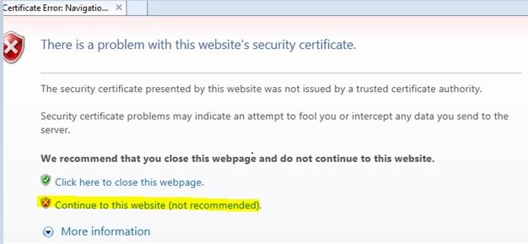  
-DBIDS Error sample above via Internet Explorer

**The application will include 5 sections as listed below:**

1. Person - Name, Date of Birth, citizenship, SSN, etc.   
2. Demographic - Gender, ethnicity, hair color, eye color, etc.   
3. Address & contact information - phone number, email address, etc.   
4. Sponsors' Information: You will need to input the following information in this section

**- Sponsor name: Rubie Blue  
- Sponsor email: rubie.blue@usmc.mil  
- Sponsor phone number: 858-307-1801**  
   
**Comments (Purpose of visit)**: in the comments section you can copy and paste the message below and make changes as they pertain to your specific class. You cannot enter more than 120 characters.

*"I’m a student with Miramar College scheduled for PSYC 101 in the Education Center in building 5305. Class is on Mon/Wed evenings from 5-815pm. The term begins on Monday, Jan 28 and ends on Sat Mar 23.*

**5. Finished - This page lets you know the application has been completed. You will need to print the last page with the DBIDs confirmation QR code and bring it with you to your appointment.**

**\*You must email a copy of your scanned confirmation with the QR code to the following: *Ron Felix- rfelix001@sdccd.edu*. Within that email, you will need to also provide to Ron the following:**

**●    Driver’s License info: *DL Number, State Issuer, and Expiration*  
●   *Date of birth***  
 

**STEP 2**: Once you complete the DBIDS application, you can obtain your temporary pass at the Pass and Decal office. Please bring the following items as required:  
   
**1. The DBIDS application confirmation QR code  
2. Bring the following documents to your appointment (you must have two forms of ID at the time of your appointment to receive your pass),**

**Authorized forms of ID:   
●    Valid State or Federally Issued Photo ID  
●    Social Security Card  
●    Birth Certificate  
●    Resident Alien Card (if not a US Citizen)   
●    Work authorization card (if not a US Citizen)   
●    US Passport**

***\*\*In order to access the base installation, you will be asked to present your valid Driver's License, current Vehicle Registration and proof of Vehicle Insurance at that time.\*\****

**3. Complete and fill out the required background check form from the following site:**

●   [https://sdmiramar.edu/sites/default/files/2021-10/secnav_5512-background_check_paperwork_pdf_0.pdf](https://www.miramar.marines.mil/Portals/164/BACKGROUND%20CHECK.pdf)  
●    **Base sponsor info: Rubie Blue; 858/307-1801**  
  
Here are some things to keep in mind that will help ensure a positive experience with the new process:  
   
*- Make sure to fill out all of the information on the DBIDS application and do not leave anything blank.  
- Complete the application as soon as possible.   
- Keep a copy of your confirmation page and do not forget to bring the DBIDS/QR confirmation page & Background check form (SECNAV 5512) when picking up your pass  
- Only enter the base through the East gate located off of Miramar Way until you have your new pass. Attempting to enter through any other gate may result in denied access*

***-Arrive at least 3 hours before the start of your class if you’re picking up your temporary pass on the first day of the term start date.***  
   
***\*\*\*Please make sure you complete this as soon as possible, as we cannot guarantee you will be granted base access if this step is not completed within 7-10 days prior to the start date of your class. Please reply to this email to confirm receipt along with scanning and attaching your DBIDs registration QR code to the email.\*\*\****  
   
The Pass & ID office is located at the East Gate off of Miramar Way; they operate Monday through Friday 7:30am - 3:30pm and can be reached at 858-307-1463. You will be able to pick-up your base pass which will be valid for the duration of the 8-week session, up to 5 business days prior to the term start date. It is recommended you arrive at least 2-3 hours before the pass office closes to ensure you will receive your temporary pass in a timely manner. You may be asked to show your valid Driver's License, current vehicle registration and proof of vehicle insurance at that time.

If you have any questions, please contact the Dean's Office at 619-388-7873 or our base office at 858-536-4329.