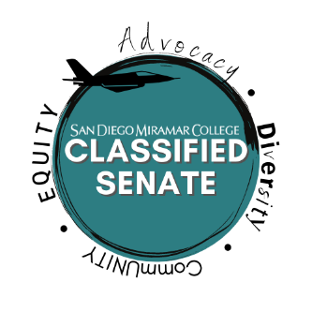
SAN DIEGO MIRAMAR COLLEGE

CLASSIFIED SENATE MEETING AGENDA

Tuesday, October 5th, 2021 11:00 a.m. - 12:00 p.m. via Zoom
0

- Call to Order

- Approval of Agenda

- Approval of Previous Minutes (5 mins.)
- Classified Senate Meeting – September 9, 2021
- Classified Senate Meeting – September 21, 2021 (not available)

- Additional Items:
- Ongoing dialogue: Equity

- New Business:
- Vaccine Mandates and Potential Impacts on Miramar College – Discussion Item, S. Young (10 mins.)

- Policy/Practice changes regarding Classified Senate in relation to the CGH, Brown Act, and Ed Code provisions – Action Item S. Young (20 mins.)

- San Diego Miramar College Tech Plan 3.0 2nd Read, Feedback, Approval – Action Item, S. Young (10 mins.)

- Update on Standing Classified Senate Committees and Lack of Participation – Action Item, S. Young (10 mins.)
- Classified Senate Equity Committee – 1 volunteer, 5 needed for Quorum
- Classified Senate Representation Committee – 1 volunteer, 5 needed for Quorum
- Classified Senate Prof. Development Committee – no volunteers

- Volunteers Needed for Special Election Committee, Two Positions Available Vice President and Senator –
Action Item, S. Young (5 mins.)

- Old Business:
- Presentation and Interactive Discussion with Steinberg Hart regarding Facilities Master Planning.

- Announcements
- Adjournment

San Diego Miramar College 2020 – 2027 Strategic Goals

- Pathways - Provide student-centered pathways that are responsive to change and focus on student learning, equity, and success
- Engagement - Enhance the college experience by providing student-centered programs, services, and activities that close achievement gaps, engage students, and remove barriers to their success
- Organizational Health - Strengthen Institutional Effectiveness through planning, outcomes assessment, and program review processes in efforts to enhance data-informed decision making
- Relationship Cultivation - Build and sustain a college culture that strengthens participatory governance, equity efforts, and community partnerships
- Diversity, Equity, and Inclusion - Build an environment that embraces diversity, equity, inclusion, anti-racism, and social justice for the benefit of the college community

Additional items will be addressed contingent upon time.

