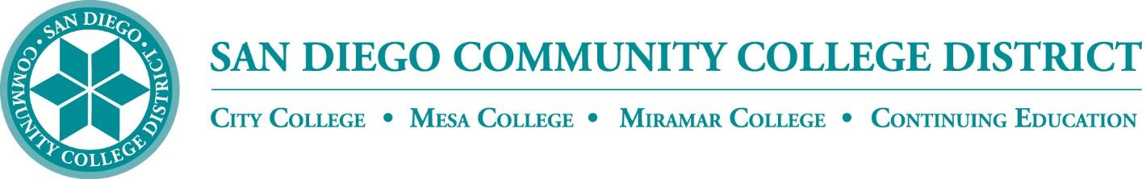

CURRICULUM COMMITTEE

MEETING AGENDA

San Diego Miramar College
Curriculum Committee
October 6, 2021 – 2:30-4:30 PM - https://cccconfer.zoom.us/j/96691399291
(password: crc)

Members: Jon Alva; Matthew Cain; Isabella Feldman; MaryAnn Guevarra; Christina Hambrick; Max Moore*; Kelly Morelewski*; Jennifer Ock; Michael Odu; Larry Pink; Mara Palma-Sanft; Wayne Sherman; Alex Stiller-Shulman; Ryan Zimmerman

*Permanent Guests

- Introductions
- Approval of agenda
- Approval of minutes from last meeting
- Approval of consent agenda
- Course proposals
  - New courses
    - SERV 103 Service Learning in International Communities
  - Activations
    - PHIL 131 Environmental Ethics
  - Deactivations
  - Revisions
    - SERV 101 Service Learning on Campus
    - SERV 102 Service Learning in the Community
- Award Proposals
  - New awards
  - Deactivations
  - Revisions
- Other business
  - California Community Colleges Ethnic Studies requirement
- Next Scheduled Meeting:
  - Wednesday, 10/20, at 2:30 PM
- Reports
  - Vice President of Instruction
  - Evaluator
  - Articulation Officer
  - Curriculum Chair
- Roundtable
Consent Agenda

(Miramar-originated two- and six-year reviews without substantive changes):
- FIPT 102

