**FA Electronic Consent Activity Guide that was recently launched in production over the weekend for the 21-22 aid year.**

I’m hoping this information will be helpful to you if you encounter a student that may have questions regarding this federal requirement that we are now enforcing.

**This requirement is part of 34 CFR 668.165. (The Electronic Signatures in Global and National Commerce Act or E-Sign Act)**

*A school must obtain a student’s voluntary consent to participate in electronic transactions.  Voluntary consent to participate in electronic transactions is required for all financial information provided or made available to student loan borrowers and for all notices and authorizations to FSA recipients*

A step by step job aid is available for students here: <https://mysdccd.atlassian.net/l/c/stACB9HK> on how to complete the FA EC Activity Guide in Student Portal.

Below is a shortened version to give you an idea of what will be displayed to students in Student Portal and the steps that they need to complete.

**Step 1**

Students will see in Student Portal the Electronic Consent activity guide as an outstanding task on their To Do List.

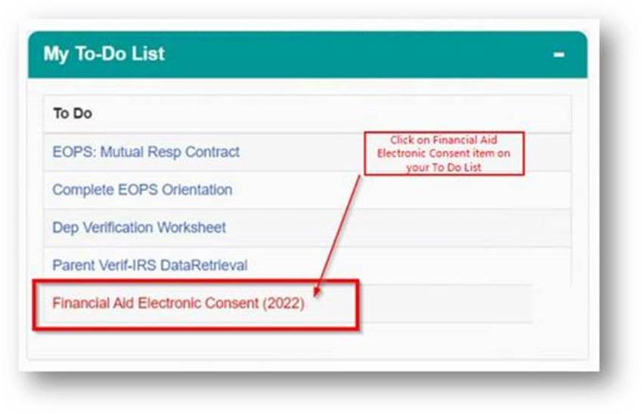

**Note:** *Until the student completes the activity guide they will not have access to their 21-22 aid year in FA Student Self-Service. Once they complete the activity guide, the following day they should be able to access their 21-22 aid year information.*

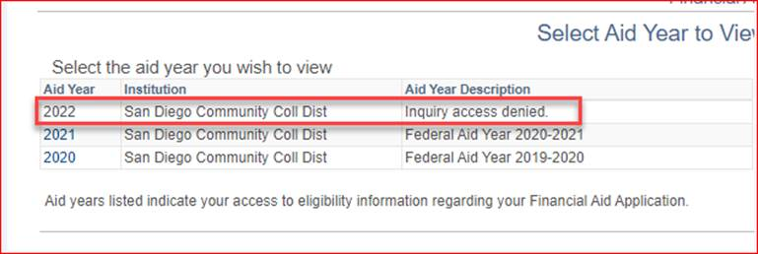

**Step 2**

After clicking on the item in their To Do List, they will be brought to the FA Electronic Consent activity guide.

There are two tasks that they need to complete in order for the completion of the activity guide to be recorded successfully. Students can exit the activity guide prior to completing and it will still show up as an outstanding item on their To Do List.

However, they will still be restricted from certain FA electronic transactions until it is completed. **It is in their best interest to complete it otherwise it may cause delays with FA processing.**

**Task #1**

Financial agreement provides the student with instructions on how to complete the activity guide and the terms that need to be consented to. The student must click Accept and Save in order to advance to the next task.

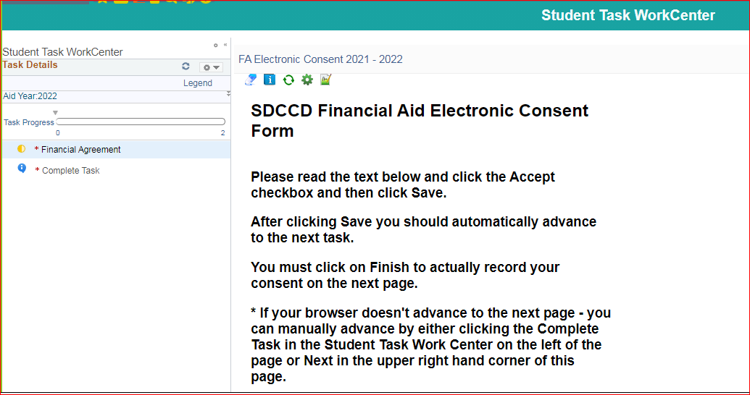

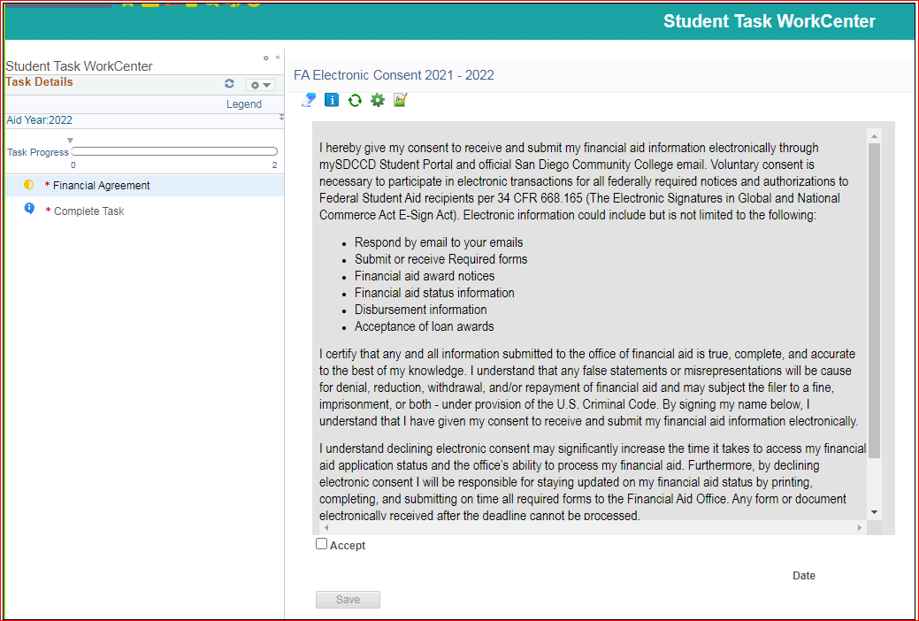

**Task #2**

Complete task is how the completion of the activity guide and consent will be recorded. If the student does not complete this task they will not be eligible for electronic transactions still.

The student will need to click Finish and it will automatically redirect the student to the Student Dashboard once done.

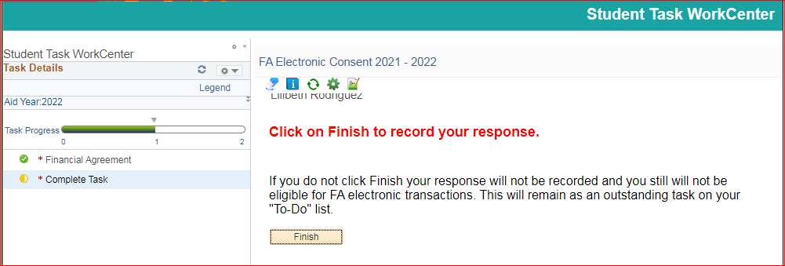

**Thank You!!!**