**Don’t take Math 96! Take Math 119X or Math 116X instead! Less time, less money AND you get college credit.**

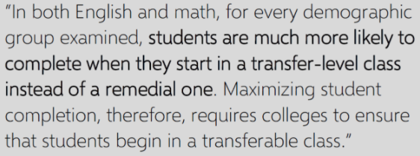**At Miramar College we are phasing out Math 96 because students are more successful if they start in a transfer-level math class:**

**California Accelerated Project Report**

**We do not recommend Math 96 for any student. Here are some better choices for students with a M30 or M40 entry level.**

**Students who plan to take Math 104, 141, 150, etc.**

**AS, AA, AST degree and certificate students:**

**Before: Math 96**

**Before: Math 96**



**Math 116x or Math 119x**

**Math 116x**

**Students who need a college level math class for transfer**

**Students who plan to take Math 121, 122.**

000

**Math 116x**

**Math 116x or**

**Math 119X**

**Just say NO to Math 96.**

**Contact Francois (**[**fbereaud@sdccd.edu**](mailto:fbereaud@sdccd.edu)**) or Julia (**[**jmcmenam@sdccd.edu**](mailto:jmcmenam@sdccd.edu)**)**